**An Exploration of Electricity**

**Consumption Pattern**

**1. Introduction:**

* 1. **overview**

**India is the world’s largest producer and third largest consumer of electricity. To analyze the consumption of electricity in COVID-19 lockdown period and to analyze the impact of the lockdown on economic activities have been faced by every sector in a positive or a negative way.**

* 1. **Purpose**

**Analysing Electricity consumption in India from Jan 2019 till 5th Dec 2020.The dataset contains a record of electricity consumption in each state of India, here we have to analyse State wise, Region wise and overall electricity consumption in India.**

**2.Problem Definition & Design Thinking:**

**2.1 Empathy map**

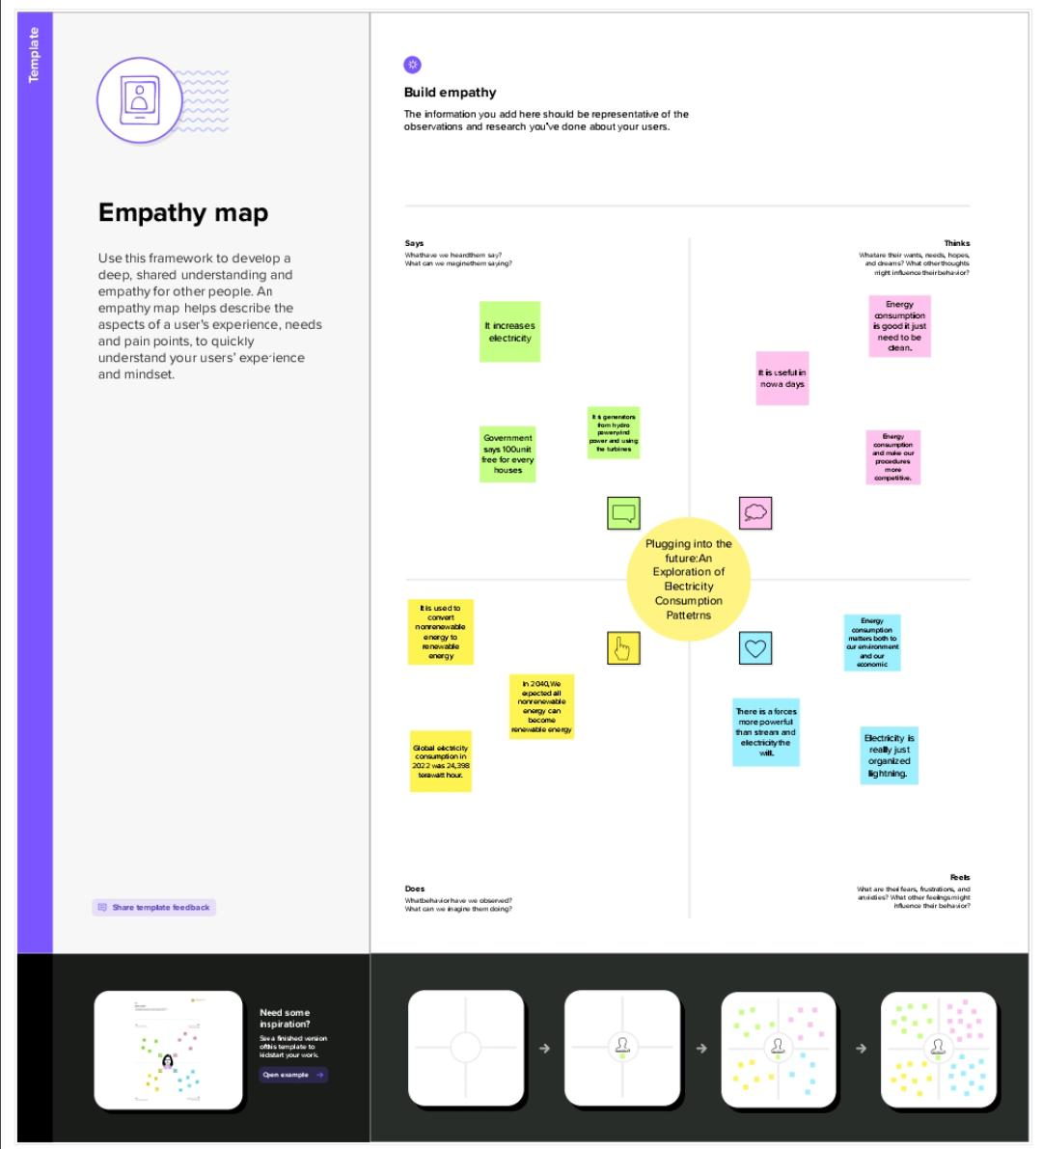

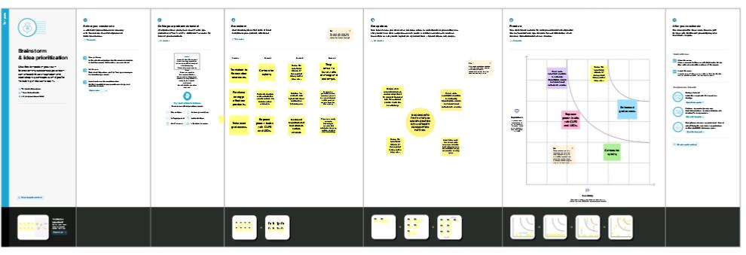**2.2 Brainstorming map & Ideation**

**3.Final finding of the Project**

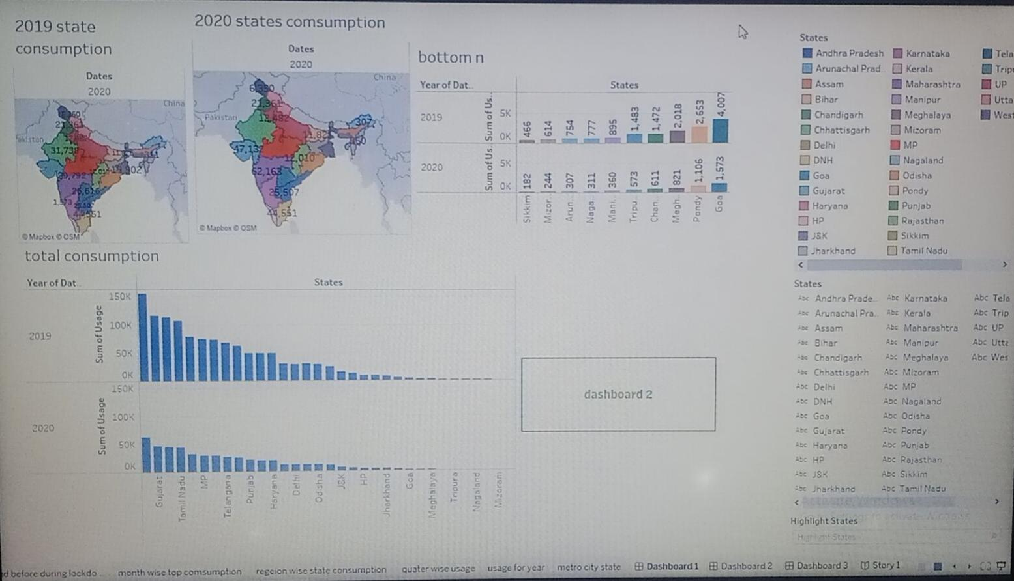

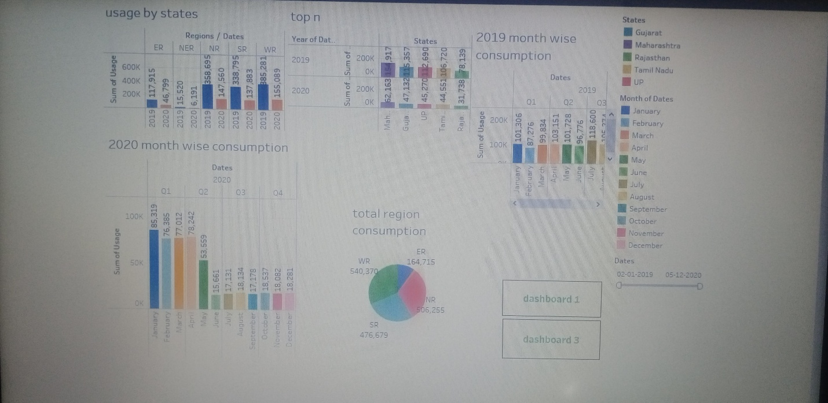

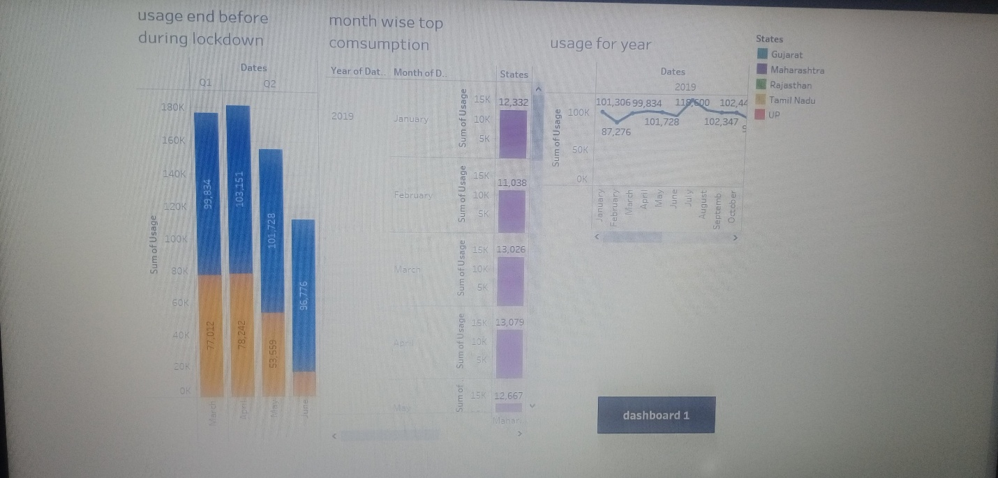

**4. Advantages & Disadvantages :**

**4.1 Advantages**

**There are several advantages of electricity consumption pattern in India:**

**Economic growth: Electricity is a key driver of economic growth. In India, increased, business and infrastructure, creating job opportunities and contributing to overall economic development.**

**Improved standard of living: Electricity consumption has improved the standard of living for the millions of people in India. Access to electricity has led to better lighting, heating and cooling in homes, improving living conditions and providing opportunities for education, entertainment and communication.**

**Rural electrification: The Indian government has made significant efforts to improve electricity access in rural villages.**

**Health and well-being: Electricity plays a critical role in improving health and well-being. Access to electricity to enables the use of electric appliances for cooking, lighting, and refrigeration, reducing indoor air pollution from traditional cooking fuels and improving health outcomes.**

**Increased productivity: Electricity consumption has resulted in increased productivity across various sectors, including agriculture, manufacturing and services.**

**Disadvantages:**

**Inadequate infrastructure: India faces challenges in terms of its electricity infrastructure, including inadequate transmission and distribution networks, outdated technology, and losses in transmission and distribution due to theft and technical inefficiencies.**

**Lack of energy efficiency: energy efficiency practices and technologies are not widespread in India, leading to inefficient electricity consumption pattern. This includes the use of inefficient appliances, outdated industrial process, and inadequate building design. Low energy efficiency not only leads higher electricity consumption but also increases green house gas emissions and contributes to environmental degradation.**

**5. Applications :**

**Energy planning and policy : understanding the electricity consumption pattern can help for formulating energy planning and policy decision. by analysing historical data on electricity consumption, policy maker can identify the trends and pattern that can inform decision related to energy Infrastrucure development , demand side management, renewable energy integration.**

**Energy efficiency : analysing electricity consumption pattern can identify areas where energy efficiency measures can be implemented. By understanding when and where electricity consumped most, energy efficiency programs can be treated to reduce energy wastage, optimize equipment operation, and promote energy efficient practice consumers and industries.**

**6.Conclusion :**

**Increaseing overall consumption : India’s electricity consumption has been steadily increasing over the years due to rising pollution, economic growth, and increased electrification in rural areas. This trend is expected to continue in the future as the demand for electricity continuous to grow.**

**7. Future scope :**

**The future scope of electricity consumption pattern in India is likely to be influenced by urbanization, economic growth, renewable energy integration, electrification of transportation, energy efficiency measures, and government policies. It is crucial for policymakers, regulators and stakeholders to plan and manage electricity consumption pattern in a sustainable manner to ensure reliable, affordable, and environmental friendly electricity supply in future.**

**Dashboard :**

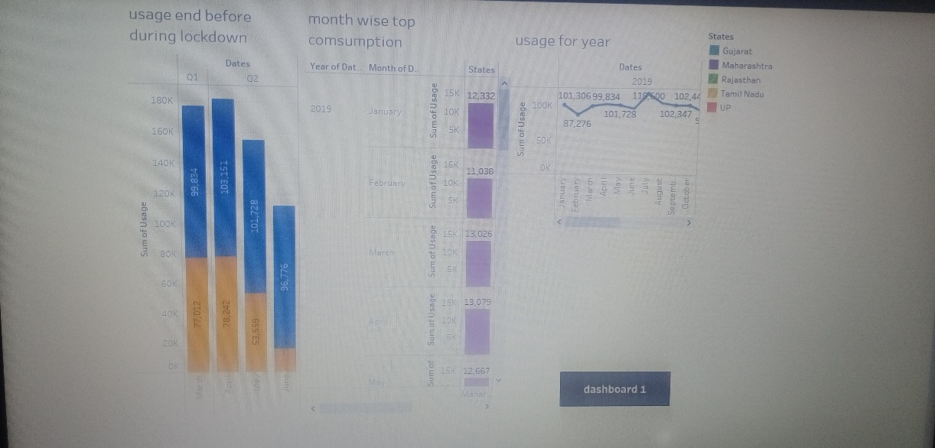



**8.Appendix :**

**Story:**

**<div class='tableauPlaceholder' id='viz1682143205601' style='position: relative'><noscript><a href='#'><img alt='Story 1 ' src='https:&#47;&#47;public.tableau.com&#47;static&#47;images&#47;El&#47;Electricityconsumption-story&#47;Story1&#47;1_rss.png' style='border: none' /></a></noscript><object class='tableauViz' style='display:none;'><param name='host_url' value='https%3A%2F%2Fpublic.tableau.com%2F' /> <param name='embed_code_version' value='3' /> <param name='site_root' value='' /><param name='name' value='Electricityconsumption-story&#47;Story1' /><param name='tabs' value='no' /><param name='toolbar' value='yes' /><param name='static_image' value='https:&#47;&#47;public.tableau.com&#47;static&#47;images&#47;El&#47;Electricityconsumption-story&#47;Story1&#47;1.png' /> <param name='animate_transition' value='yes' /><param name='display_static_image' value='yes' /><param name='display_spinner' value='yes' /><param name='display_overlay' value='yes' /><param name='display_count' value='yes' /><param name='language' value='en-US' /></object></div> <script type='text/javascript'> var divElement = document.getElementById('viz1682143205601'); var vizElement = divElement.getElementsByTagName('object')[0]; vizElement.style.width='1016px';vizElement.style.height='991px'; var scriptElement = document.createElement('script'); scriptElement.src = 'https://public.tableau.com/javascripts/api/viz_v1.js'; vizElement.parentNode.insertBefore(scriptElement, vizElement);        </script>**

**Dashboart:**

**<div class='tableauPlaceholder' id='viz1682143220032' style='position: relative'><noscript><a href='#'><img alt='Dashboard 1 ' src='https:&#47;&#47;public.tableau.com&#47;static&#47;images&#47;El&#47;Electricityconsumption-dashboard&#47;Dashboard1&#47;1_rss.png' style='border: none' /></a></noscript><object class='tableauViz' style='display:none;'><param name='host_url' value='https%3A%2F%2Fpublic.tableau.com%2F' /> <param name='embed_code_version' value='3' /> <param name='site_root' value='' /><param name='name' value='Electricityconsumption-dashboard&#47;Dashboard1' /><param name='tabs' value='no' /><param name='toolbar' value='yes' /><param name='static_image' value='https:&#47;&#47;public.tableau.com&#47;static&#47;images&#47;El&#47;Electricityconsumption-dashboard&#47;Dashboard1&#47;1.png' /> <param name='animate_transition' value='yes' /><param name='display_static_image' value='yes' /><param name='display_spinner' value='yes' /><param name='display_overlay' value='yes' /><param name='display_count' value='yes' /><param name='language' value='en-US' /></object></div> <script type='text/javascript'> var divElement = document.getElementById('viz1682143220032'); var vizElement = divElement.getElementsByTagName('object')[0]; if ( divElement.offsetWidth > 800 ) { vizElement.style.width='100%';vizElement.style.height=(divElement.offsetWidth*0.75)+'px';} else if ( divElement.offsetWidth > 500 ) { vizElement.style.width='100%';vizElement.style.height=(divElement.offsetWidth*0.75)+'px';} else { vizElement.style.width='100%';vizElement.style.height='1527px';} var scriptElement = document.createElement('script'); scriptElement.src = 'https://public.tableau.com/javascripts/api/viz_v1.js'; vizElement.parentNode.insertBefore(scriptElement, vizElement);        </script>**